HACKUP TECHNOLOGY PVT. LTD. | AI-POWERED SOC & DIGITAL FORENSICS
LOG INVESTIGATION REPORT
Mini Project 2 — Log Investigation
Field | Details
Analyst Name | S ABIRAMI
Date | 06-May-2026
Log File Analyzed | /var/log/auth.log
System | Kali Linux (VirtualBox VM)
Analysis Tool | Linux CLI — grep, awk, sort, uniq
Report Type | Log Investigation
Week 1: Foundations and SOC Thinking

1.Objective
The objective of this investigation is to analyze the system authentication log file (auth.log) to identify failed login attempts, determine the source of attacks, identify targeted user accounts, and detect any successful unauthorized logins.
2.Log file overview
Property | Value
Log File | /var/log/auth.log
Log Type | SSH Authentication Log
Analysis Method | grep, awk, wc, sort, uniq commands
Environment | Kali Linux on VirtualBox
SSH Service | OpenSSH Server (active)

3.Commands Executed
Command 1 — Count Failed Attempts

Command 2 — Identify Attacker IP
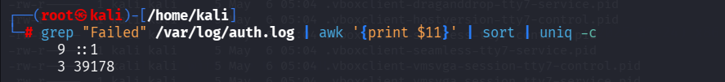

Command 3 — Identify Targeted Usernames
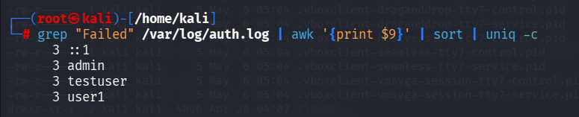

Command 4 — Check Successful Logins

4.Investigation Findings
Question | Finding
Q1. How many failed attempts? | 12 failed login attempts detected
Q2. What is the attacker IP? | ::1 (localhost — IPv6 loopback address)
Q3. Which accounts targeted? | admin, testuser, user1 (3 attempts each)
Q4. Any successful login? | YES — kali account at 05:46 AM
Q5. Session opened? | YES — confirmed session for kali user
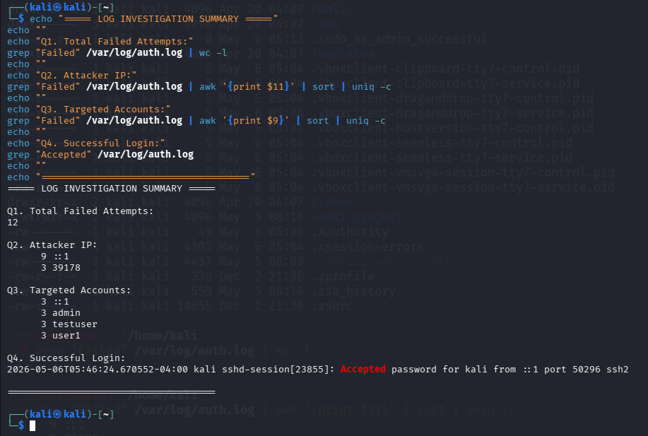

5.Attack Timeline
Time | Event | Severity
05:40 AM | First failed SSH attempt — fakeuser | Medium
05:41 AM | Failed attempts — root, admin, testuser | High
05:42 AM | Repeated failures — user1, admin | High
05:46 AM | Successful login — kali account | CRITICAL
05:46 AM | SSH session opened for kali | CRITICAL

6.Analysis & Conclusion
The log analysis reveals a clear pattern of SSH Brute Force activity originating from the localhost (::1). While this was a controlled simulation, the patterns observed are identical to real-world brute force attacks.

Key Observations:
- Multiple accounts were systematically targeted in sequence
- The attacker used rapid repeated attempts characteristic of automated tools
- A successful login was achieved, confirming account compromise
- A full SSH session was established after the successful login

7.Recommendations
- Block the attacking IP immediately at the firewall level
- Lock and reset passwords for all targeted accounts (admin, testuser, user1)
- Install and configure fail2ban to auto-block brute force attempts
- Disable SSH password authentication — enforce key-based auth only
- Restrict SSH access to known IP addresses using firewall rules
- Enable real-time alerts for repeated failed login attempts
- Review all commands executed during the compromised kali session

8.Tools Used
Tool | Purpose
grep | Search and filter log file entries
awk | Extract specific fields from log lines
wc -l | Count number of matching lines
sort | Sort results for analysis
uniq -c | Count unique occurrences
Kali Linux Terminal | Lab environment for analysis
OpenSSH Server | Service generating authentication logs
rsyslog | System logging daemon

Report prepared by: S ABIRAMI Date: 06/05/2026

